Dis-Afr-Mauritania-Dhrayya‘ Mâlichigdâne-Acheulian-Cordiform Hand Axe

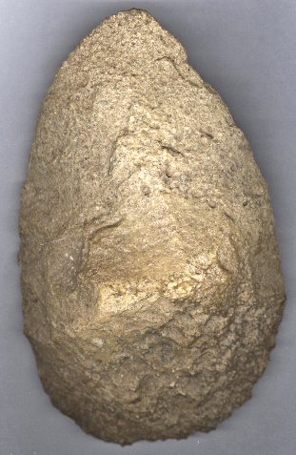

Figs 1-2. Cordiform Acheulian Hand Axe, from

Dhrayya‘ Mâlichigdâne, Mauritania, ventral and Dorsal views.

**Formal Label:** Cordiform Acheulian Hand Axe, from Dhrayya‘ Mâlichigdâne, Mauritania

**Accession Number: A21**

**LC Classification:** GN 280

**Date or Time Horizon:** 150,000 BP

**Geographical Area:** **Dhrayya 'Mâlichigdâne** dune, Adrar, [20.11505 ° N 13.58793 ° W](https://translate.googleusercontent.com/translate_c?depth=1&hl=en&prev=search&rurl=translate.google.com&sl=sv&sp=nmt4&u=https://tools.wmflabs.org/geohack/geohack.php%3Flanguage%3Dsv%26pagename%3DDr%25C3%25A2%25E2%2580%2599_Malichigdane%26params%3D20.11505_N_-13.58793_E_region:MR_type:adm1st%26title%3DDhrayya%27%2BM%25C3%25A2lichigd%25C3%25A2ne&usg=ALkJrhi_t0U-0zuhYw1PLlzUr7pPOgBEDg)

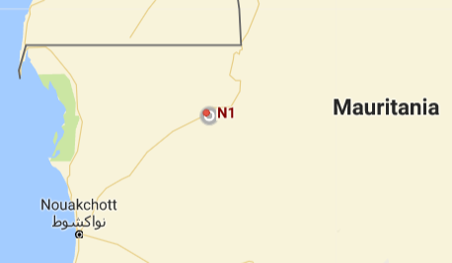 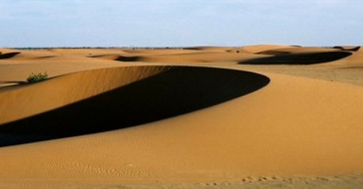

Figs. 3-4. Dhrayya‘ Mâlichigdâne. Fig 3. From <http://www.geonames.org/2378124/dhrayya-malichigdane.html>. Fig 4. From from <http://www.i-trekkings.net/bibliotheque/Gregory-rohart/amatlich/05.jpg>

**Cultural Affiliation:** Acheulian

**Medium:** Silicified sandstone.

**Dimensions: H 14.7 cm; W 9.7 cm.  
Weight:**

**Provenance: from an old English collection**

**Condition:** Museum quality

**Discussion:** The terrain around the Dhrayya 'Mâlichigdâne dunes in the region of Adrar is very flat (see Fig. 4, above) and desiccated with an average annual rainfall of 88 mm, almost no vegetation (Nasa 2016b) and less than two inhabitants per km2 (Nasa 2016a). This is attributed to the current hot desert climate. Although, today there are no nearby communities, there are more named dunes within a 20 km radius compared to the average of those named in similar places on earth, according to GeoNames (2016). This suggests that in the past there was a greater population in the area, the memory of which has been retained. The area was lush with vegetation 150,000 BP, and various antelope and smaller mammals were in abundance. Therefore, these cordiform Acheulian biface axes and other Acheulian tools were in use to hunt these animals.

**References:**

**Geonames 2016. “**[Dhrayya 'Mâlichigdâne](https://translate.googleusercontent.com/translate_c?depth=1&hl=en&prev=search&rurl=translate.google.com&sl=sv&sp=nmt4&u=http://www.geonames.org/2378124/dhrayya%27%2520malichigdane.html&usg=ALkJrhhZtUrZaBejzqs7l-_XCw-9P3duxg),” of [Geonames.org (CC-BY)](https://translate.googleusercontent.com/translate_c?depth=1&hl=en&prev=search&rurl=translate.google.com&sl=sv&sp=nmt4&u=http://www.geonames.org/about.html&usg=ALkJrhiQf6SYxy1KLkW_7fXAUySrkjvSng)

Peel, M.C.; B. L. Finlayson; T.A. McMahon 2007. “[Updated world map of the Köppen-Geiger climate classification](https://translate.googleusercontent.com/translate_c?depth=1&hl=en&prev=search&rurl=translate.google.com&sl=sv&sp=nmt4&u=http://www.hydrol-earth-syst-sci.net/11/1633/2007/hess-11-1633-2007.html&usg=ALkJrhiRrjP5LP1IUJ9hdKhjHJ57Y2fejA),” Hydrology and Earth System Sciences 11: p. 1633-1644.

Nasa 2016a. [“NASA Earth Observations: Population Density.”](https://translate.googleusercontent.com/translate_c?depth=1&hl=en&prev=search&rurl=translate.google.com&sl=sv&sp=nmt4&u=http://neo.sci.gsfc.nasa.gov/view.php%3FdatasetId%3DSEDAC_POP&usg=ALkJrhjCU1vuW2xkzlFWPudtqaBUAJSj0g)

Nasa 2016b. [“NASA Earth Observations: Land Cover Classification.”](https://translate.googleusercontent.com/translate_c?depth=1&hl=en&prev=search&rurl=translate.google.com&sl=sv&sp=nmt4&u=http://neo.sci.gsfc.nasa.gov/view.php%3FdatasetId%3DMCD12C1_T1&usg=ALkJrhhq33hTEtH8zhuTKcHTheH0W2yExA)